|  |
| --- |
| **Lab07: Inheritance** |

Designing and implementing Java programs that deal with:

|  |
| --- |
| 1. Inheritance (in Java) 2. Exercise for practice |

|  |
| --- |
| **Exercises** |

Exercise 1 (Department)

The UML diagram of a system is given that contains the following classes.Write Java code for these classes.

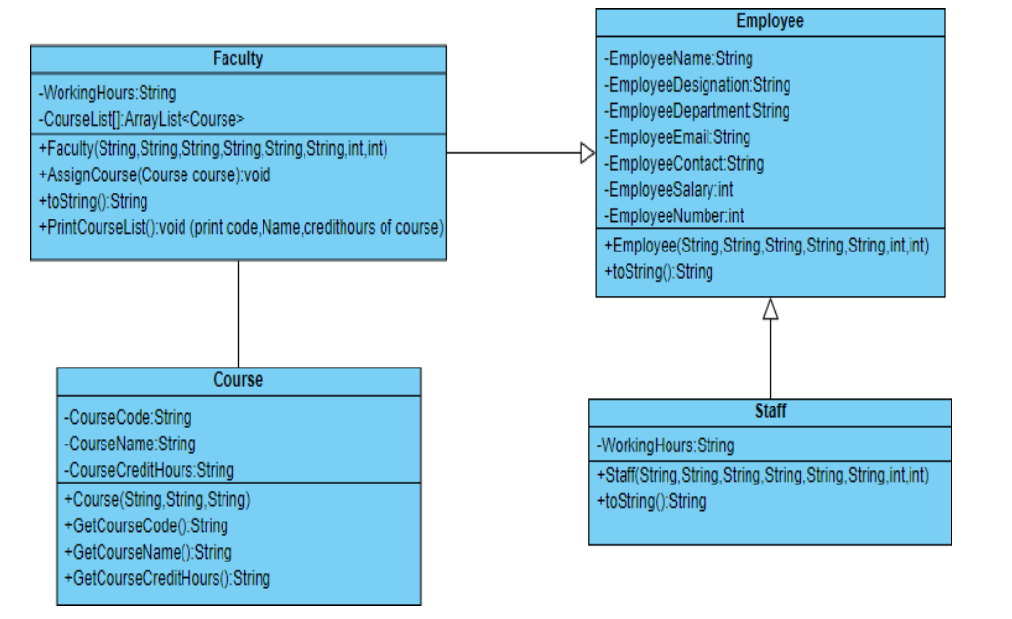

Implement all classes given in UML diagram.

Create Driver class named as **Inheritance_1.** Create proper Objects of all classes as follows

* Create Two objects of Staff class
* Create Two Objects of Faculty Class
* Create Three Objects of Course class

Assign each Faculty courses of your choice and properly display all the information of Faculty, assignedcourses and staff members

**Source Code:**

**Employee:**

package department;

public class Employee {

private String name;

private String designation;

private String department;

private String email;

private String contact;

private double salary;

private int number;

public Employee(String name, String designation, String department, String email, String contact, double salary, int number) {

this.name = name;

this.designation =designation;

this.department =department;

this.email =email;

this.contact =contact;

this.salary = salary;

this.number =number;

}

public String getName() {

return name;

}

public String getDesignation() {

return designation;

}

public String getDepartment() {

return department;

}

public String getEmail() {

return email;

}

public String getContact() {

return name;

}

public double getSalary() {

return salary;

}

public int getNumber() {

return number;

}

@Override

public String toString() {

return "Employee [Name: " + name + " , Designation: "+designation+" , Department: "+ department +" , Email: "+ email +" , Contact: "+ contact +" Salary: " + salary + " , Number: "+ number +"]";

}

}

**Staff:**

package department;

public class Staff extends Employee {

private int workingHours;

public Staff(String name, String designation, String department, String email, String contact, double salary, int number, int workingHours) {

super(name, designation, department, email, contact, salary, number);

this.workingHours = workingHours;

}

public int getWorkingHours() {

return workingHours;

}

@Override

public String toString() {

return super.toString() + ", Working Hours: " + workingHours;

}

}

**Faculty:**

package department;

import java.util.ArrayList;

public class Faculty extends Employee{

private int workingHours;

private ArrayList<Course> courses;

public Faculty(String name, String designation, String department, String email, String contact, double salary, int number, int workingHours) {

super(name, designation, department, email, contact, salary, number);

this.workingHours = workingHours;

this.courses = new ArrayList<>();

}

public void addCourse(Course course) {

courses.add(course);

}

public ArrayList<Course> getCourses() {

return courses;

}

public int getWorkingHours() {

return workingHours;

}

@Override

public String toString() {

StringBuilder facultyInfo = new StringBuilder(super.toString() + ", Working Hours: " + workingHours + "\nCourses:");

for (Course course : courses) {

facultyInfo.append("\n- ").append(course);

}

return facultyInfo.toString();

}

}

**Course:**

package department;

public class Course {

private String courseName;

private String courseCode;

private int courseCreditHours;

public Course(String courseName, String courseCode, int courseCreditHours) {

this.courseName = courseName;

this.courseCode = courseCode;

this.courseCreditHours = courseCreditHours;

}

public String getCourseName() {

return courseName;

}

public String getCourseCode() {

return courseCode;

}

public int getCourseCreditHours() {

return courseCreditHours;

}

@Override

public String toString() {

return "Course [Name: " + courseName + ", Code: " + courseCode + ", Credit Hours: " + courseCreditHours + "]";

}

}

**Inheritance_1:**

package department;

public class Inheritance_1 {

public static void main(String[] args) {

Staff staff1 = new Staff("Zunaira", "Administrator", "HR", "zoni@gmail.com", "030949790", 87654, 011, 70);

Staff staff2 = new Staff("Umar", "Technician", "IT", "umar@gmail.com", "0346778921", 9890, 002, 30);

Course course1 = new Course("OOP", "CS101", 3);

Course course2 = new Course("Data Structures", "CS102", 3);

Course course3 = new Course("Databases And Algorithms", "CS103", 3);

Faculty faculty1 = new Faculty("Dr. Asna", "Professor", "Computer Science", "asna@gmail.com", "09871234", 7000, 201, 40);

faculty1.addCourse(course1);

faculty1.addCourse(course2);

Faculty faculty2 = new Faculty("Dr. Ambreen", "Associate Professor", "Information Technology", "ambreen@gmail.com", "009835678", 70000, 202, 38);

faculty2.addCourse(course3);

System.out.println("Staff Members:");

System.out.println(staff1);

System.out.println(staff2);

System.out.println("\nFaculty Members:");

System.out.println(faculty1);

System.out.println(faculty2);

}

}

**Output:**

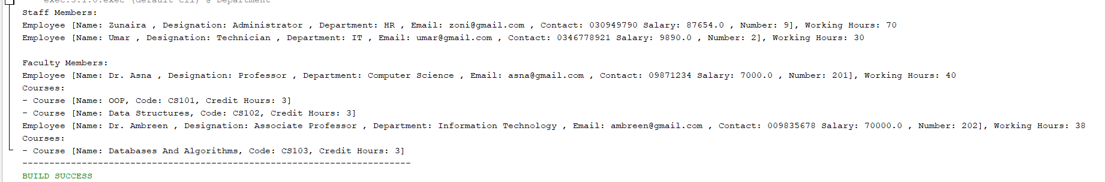

Exercise 2 (Account)

The UML diagram of a Bank Account system that contains the following classes.Write Java code for theseclasses.

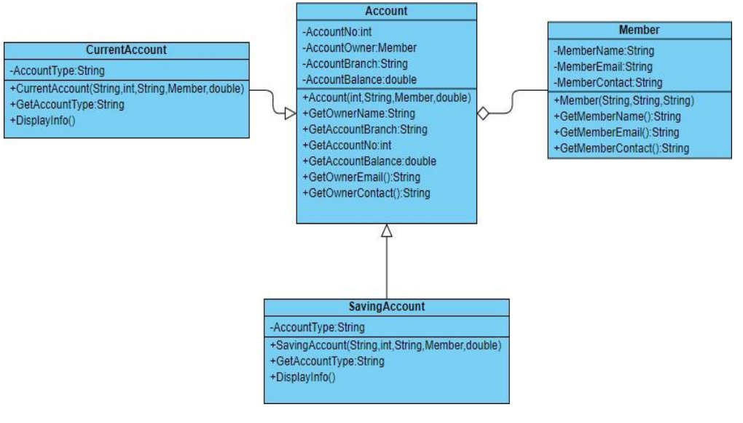

Implement all classes given in UML diagram.

Create Driver class named as Inheritance_2.

Create proper Objects of all classes as follows

Create three objects of Member class.

Two of which have current account and one has savingaccount And properly display all the information

**Source Code:**

**Inheritance_2:**

package member;

public class Inheritance_2 {

public static void main(String[] args) {

Account currentAccount1 = new CurrentAccount(106, "Talha", "Main Branch", 1000.00, "current account");

Account currentAccount2 = new CurrentAccount(302, "Rumaisa", "Main Branch", 1000.00, "current account");

Account savingAccount = new SavingAccount(102, "Umar", "City Branch", 5000.00, "saving account");

Member member1 = new Member("Talha", 106, "0324567890", currentAccount1);

Member member2 = new Member("Rumaisa", 302, "0396454578", currentAccount2);

Member member3 = new Member("Umar", 102, "0321143210", savingAccount);

System.out.println(member1);

System.out.println(member2);

System.out.println(member3);

}

**}**

**SavingAccount:**

package member;

public class SavingAccount extends Account {

private String accountType;

public SavingAccount(int accountNo, String owner, String branch, double balance, String accountType) {

super(accountNo, owner, branch, balance);

this.accountType = "Saving Account";

}

public String getAccountType() {

return accountType;

}

@Override

public String toString() {

return super.toString() + ", Account Type: " + accountType;

}

}

**CurrentAccount:**

package member;

public class CurrentAccount extends Account{

private String accountType;

public CurrentAccount(int accountNo, String owner, String branch, double balance, String accountType) {

super(accountNo, owner, branch, balance);

this.accountType = "Current Account";

}

public String getAccountType() {

return accountType;

}

@Override

public String toString() {

return super.toString() + ", Account Type: " + accountType;

}

}

**Account:**

package member;

public class Account {

private int accountNo;

private String owner;

private String branch;

private double balance;

public Account(int accountNo, String owner, String branch, double balance) {

this.accountNo = accountNo;

this.owner = owner;

this.branch = branch;

this.balance = balance;

}

public int getAccountNo() {

return accountNo;

}

public String getOwner() {

return owner;

}

public String getBranch() {

return branch;

}

public double getBalance() {

return balance;

}

@Override

public String toString() {

return "Account \n[Account No: " + accountNo + ", Owner: " + owner + ", Branch: " + branch + ", Balance: " + balance + "]";

}

}

**Member:**

package member;

public class Member {

private String name;

private int id;

private String contact;

private Account account;

public Member(String name, int id, String contact, Account account) {

this.name = name;

this.id = id;

this.contact = contact;

this.account = account;

}

public String getName() {

return name;

}

public int getId() {

return id;

}

public String getContact() {

return contact;

}

public Account getAccount() {

return account;

}

@Override

public String toString() {

return "Member [Name: " + name + ", ID: " + id + ", Contact: " + contact +" "+ account + "]";

}

}

**Output:**

